**Chemistry – Semester 1 Exam Study Guide**

**At the end of each chapter there are starred questions that have the answers printed in appendix E. Take advantage of these!**

**Chapter 1:**

1. What is matter?
2. List the 5 areas of study in chemistry and know what they involve.
3. Explain the “big ideas” in chemistry.
4. What is technology and how is it related to chemistry?
5. Know the steps of the scientific method as well as how to identify the independent/dependent variables, constants.
6. What is the difference between a theory and a law?

**Chapter 2:**

1. Extensive vs. intensive properties
2. Physical vs. chemical properties
3. Substance vs. mixture
4. States of matter – list and describe characteristics of each
5. Physical vs. chemical changes
6. Homogeneous vs. heterogeneous mixtures – describe and give examples
7. Another name for homogeneous mixtures
8. C:\Users\mahenry\AppData\Local\Microsoft\Windows\Temporary Internet Files\Content.IE5\1W6EUVEA\MC900233971[1].wmfDescribe methods of separating mixtures
9. Elements vs. compounds – describe and give examples
10. How is periodic table arranged? Groups? Periods?
11. Evidence that chemical change has occurred
12. Reactants? Products?
13. Law of conservation of mass

**Chapter 3:**

1. Know how to write numbers in scientific notation.
2. Know how to add, subtract, multiply, divide numbers in scientific notation.
3. Know the difference between precision and accuracy in measurements.
4. Be able to calculate error and percent error.
5. Know rules for counting significant figures and rounding.
6. Be able to read laboratory equipment to the correct number of significant figures.
7. Know rules for significant figures in adding, subtracting, multiplying, dividing.
8. List the SI base units for length, mass, temperature, and time.
9. Know the meaning of commonly used metric prefixes.
10. Explain the difference between mass and weight.
11. Know how to convert between the Celsius and Kelvin scale.
12. What is absolute zero?
13. Know how to calculate density.
14. What is a conversion factor?
15. Be able to set up a problem using dimensional analysis.

**Chapter 4:**

1. What is an atom?
2. Compare the atomic models of Democritus, Dalton, Thomson, Rutherford.
3. What is Dalton’s atomic theory? Which portions have been modified?
4. What are the subatomic particles and what are their charges?
5. Describe Thomson’s cathode ray tube experiment. What did it prove?
6. Describe Rutherford’s gold foil experiment. What did it prove?
7. What is the atomic number of an element? Mass number?
8. Know how to calculate number of protons, neutrons, and electrons.
9. What are isotopes?
10. How is atomic mass calculated? What is the label?

**Chapter 5:**

1. Compare/contrast Bohr’s model with Schrödinger’s quantum mechanical model.
2. What is an atomic orbital?
3. What is a quantum?
4. What does the principle quantum number tell you?
5. What shape is the s sublevel? p?
6. How many electrons can be held in the s sublevel? p? d? f?
7. Explain the three rules governing electron configurations: Aubau, Pauli exclusion, Hund’s

7s

6s

5s

1. Be able to write electron configurations.
2. When is an energy sublevel the most stable?
3. Where are the s,p,d, and f blocks located on the periodic table?
4. Know how to determine how many valence electrons an element has.
5. What are the types of electromagnetic radiation?
6. How is a spectrum created?
7. Which color has the longest wavelength and lowest frequency? Shortest wavelength and highest frequency?
8. What is the difference between an electron in the ground state and the excited state?
9. What happens when excited electrons return to the ground state?
10. What is an atomic emission spectrum?
11. 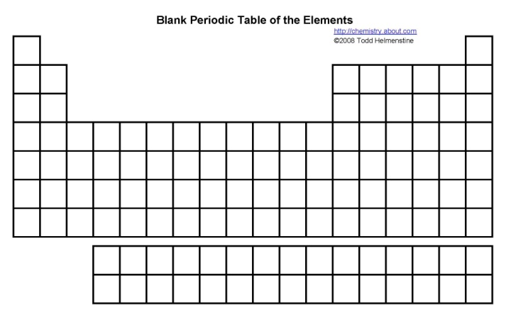 What is meant by wave-particle duality?
12. Describe the photoelectric effect.
13. What are photons?
14. How do neon lights work? Why are they different colors?
15. What does the Heisenberg uncertainty principle state?

**Chapter 6:**

1. How was Mendeleev’s periodic table organized?
2. Why did Mendeleev leave spaces in his table?
3. How is today’s table arranged?
4. What does the periodic law state?
5. Know characteristics of metals/nonmetals/metalloids and where they are located on the periodic table.
6. Know locations on the periodic table for alkali metals, alkaline earth metals, transition metals, inner transition metals, halogens, noble gases.
7. What are representative elements?
8. Know and be able to explain trends for atomic size, ionic size, electronegativity, nuclear charge, ionization energy, electron shielding.

**Chapter 7:**

1. What are valence electrons and why are they important?
2. Know how to draw electron dot structures.
3. What is the octet rule?
4. How are cations and anions formed? Know how to write their electron configurations.
5. What is an ionic compound? Ionic bonds?
6. What is a chemical formula? Formula unit?
7. List properties of ionic compounds.
8. Describe metallic bonds. What is the model for the valence electrons of metal atoms?
9. List properties of metals.
10. What are alloys and why are they important? List some examples of alloys.
11. Be able to properly name ionic compounds.

110. Elements!

