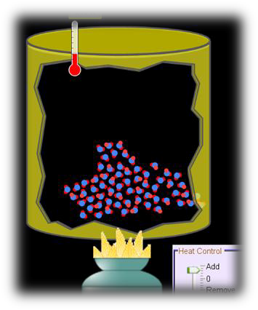
Name _______________________

PHET Simulation: States of Matter
http://phet.colorado.edu/en/simulation/states-of-matter

Experiment with the simulator to answer these questions.

Part 1: Solid, Liquid, Gas

1. Describe AND Draw the molecules in a Solid, Liquid, and Gas.
Gas -
Liquid-
Solid -

2. Which requires more energy (heat) to go from a solid to a liquid?
neon / argon /oxygen / water

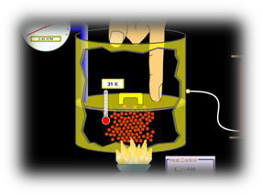
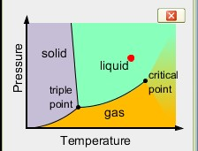
Part 2: Phase Changes

1. Adjust the heat and pressure (push down on the lid) to make neon a liquid.

Notice the red dot on the graph

What is the temperature? K
What is the pressure? _ ATM (atmospheres)

2. Try this:

➢ Cool water to 3OK (then reset the heat control to zero)
➢ Increase the pressure slowly . Can you get the ice to melt (turn to a liquid)
without adjusting the heat control? Temp _oK pressure ATM
➢ Increase the temperature further but don’t let it explode (start over if it does). Can you get the water (liquid) to turn to a gas without adjusting the heat control? Temp _ _oK pressure ATM

3. What happens to a solid when you slowly increase the pressure?

What happens if you increase the pressure too far?

PHET Simulation: States of Matter page 2

4. How can argon exist as a solid when the pressure is above 95 ATM? (What did you have to change)?

5. As the pressure of a liquid increases, its boiling point (temp at which it turns to a gas)
increases / decreases / stays the same

6. As the pressure of a liquid decreases, its boiling point increases / decreases / stays the same

7. Why does a hot dog take longer to cook in boiling water when it is high in the mountains then when it is at sea level?

8. Why does food in a pressure cooker (high pressure) cook faster than at normal pressure?

Research question – use what you learned from this activity and your research skills (Google)

9. How would our simulator explain the production of dry ice from carbon dioxide gas?

