Name ___________________________ Date _______________ Class ______________
Percentage Composition
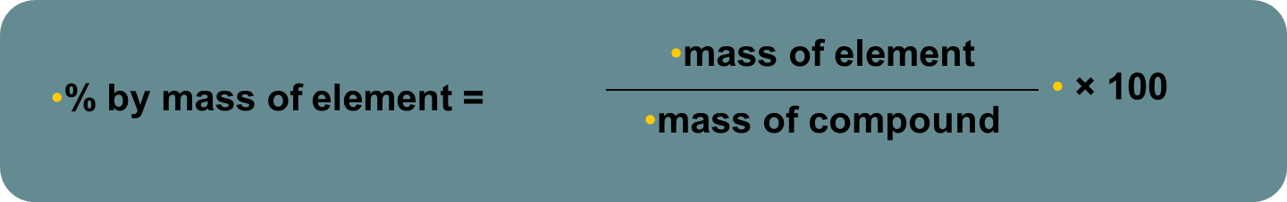
Let’s start with a step by step example you can relate to:
How many total students do we have in the class? ______
How many boys? _______
How many girls? ________
What is our classroom percent composition? Well, first we need to figure out what percentage of the class is boys. How would we do that? Show work below. Then do the same for girls. You’ve just done a percent composition problem!

Now, let’s apply to chemistry concepts.
The formula for sucrose (table sugar) is C₁₂H₂₂O_{11.}
Find the molar mass of sucrose: (SHOW YOUR WORK)

This molar mass represents the ENTIRE mass (or the ENTIRE CLASS). But in our classroom example, we divided the class into 2 groups and sucrose contains Carbon ( c ), Hydrogen (H), and Oxygen (O).
Okay, were going to break it down a little further for this first one. How much of the molecule is Carbon? Well, let’s start with finding the molar mass of JUST carbon in sucrose. Show your work.

Now find the % of carbon in sucrose. (use your classroom example to help)

Repeat these steps to find the % of H and O in sucrose as well. Show work below.

Now that we have done a few practice problems, come up with your own definition of PERCENT COMPOSITION.

Percentage Composition
Determine the percentage composition of each of the compounds below. SHOW YOUR WORK to the right of each problem!

- KMnO₄  K =_________  Mn = _________  O =_________ | - (NH₄)₃PO₄  N =_________  H = _________  P =_________  O =_________
- HCI  H =_________  Cl = _________ | - Al₂(SO₄)₃  Al =_________  S = _________  O =_________
- Mg(NO₃)₂  Mg =_________  N = _________  O =_________ | - Come up with your own make-believe compound (using real elements) with AT LEAST three elements, and find its percent composition.
Empirical Formulas
Luckily, now that you understand how to calculate percent composition, determining empirical formulas will be easy-peasy!

It’s like working backwards.
- Lets say we know a compound is made up of 75% oxygen and 25% hydrogen. What is the empirical formula of the compound?
Step 1: You have 100% to start with so we can assume that if we use 100g we have _____g Oxygen and ______ g Hydrogen.
Step 2: Start with what you know
75g O 1 mol O = 6.25 mol O
12.00 g O
25g H 1 mol H = 25 mol H
- g H

If we were to plug this into the formula, it would look like this: C_{6.25}H₂₅
Have you ever seen a formula that looks like this? _________
So we need to get one of them to be 1. So, you divide both solutions by the smallest one.
6.25mol O/6.25 = ____ mol O
25mol H/ 6.25 = ______ mol H
So the new and final EMPIRICAL formula is ____________.

Determine the empirical formulas of each of the compounds below.
- 52.7 % K and 47.3% Cl

- 22.1% Al, 25.4% P, and 52.5% O

- 13% Mg and 87% Br

Explain the process to find empirical formula in your own words in the way you understand it.

