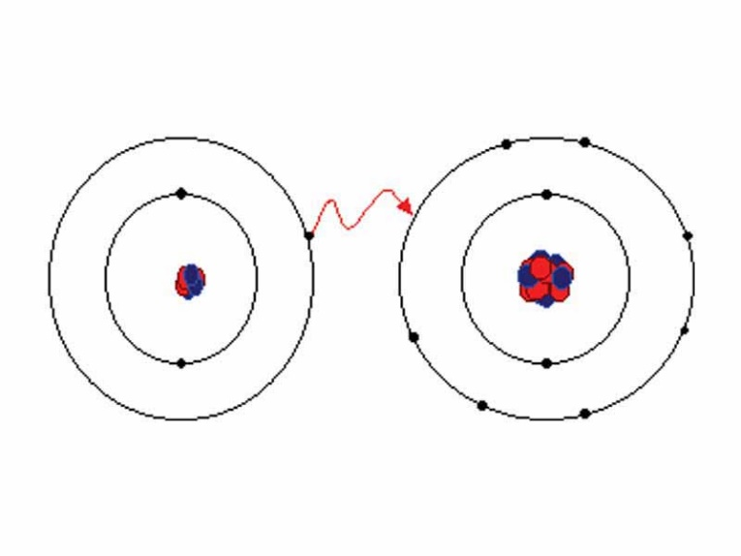
Chapter 7 Study Guide
- What makes up an ionic compound?

  - How do they form?

  - Know an ionic compound’s charge, structure, atoms, characteristics, etc.

- What is the difference between a cation and anion?

- What are valence electrons?

  - What is their importance?

  - Know how to determine the valence electrons for elements.

- What does the coordination number tell you?

- Know how to draw and identify electron dot configurations for elements, and how to show bonds using this structure.

  - Ex) Make a compound between barium and phosphide showing this with electron dot configuration. Identify the chemical formula:

- Know the Ch. 7 vocab words.

- Understand how the electron configuration changes when an atom becomes an ion.

  - Na Na+

  - As As³⁻

- Know what the charge of an ion tells you.
- Understand what an alloy is, why they are superior, and an example of an alloy commonly used.

  - What is a substitutional alloy?

  - What is an interstitial alloy?

- Know what a metallic bond is and how it is described.

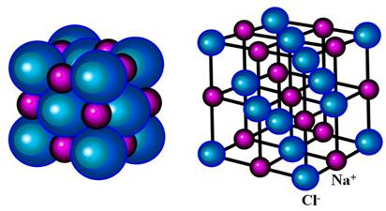
  - What type of structure do metallic bonds have?

