Chapter 6 Study Guide

- Be able to identify these groups on the periodic table:
Alkali metals Alkaline metals Transition metals Metalloids
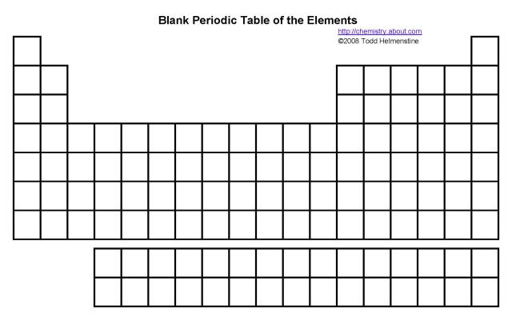
Nonmetals Halogens Noble Gases
- Be able to identify these trends on the periodic table using arrows:
Electronegativity ionization energy atomic radius
- Define electronegativity in your own words:

  - Explain WHY this trend changes from left to right and from top to bottom across the table:

- Define ionization energy in your own words:

  - Explain WHY this trend changes from left to right and from top to bottom across the table:

- Define atomic radius in your own words:

  - Explain WHY the atomic radius changes from left to right and from top to bottom across the table:

- What is the difference between a cation and an anion?

  - What is the difference in size between a cation and an atom of the same element?

  - What is the difference in size between an anion and an atom of the same element?

- Which direction do periods run on the periodic table? (left to right or top to bottom)

  - What can these numbers tell you?

- Which direction do groups run on the periodic table? (left to right or top to bottom)

  - What changes as these numbers increase?

