**C:\Users\mahenry\AppData\Local\Microsoft\Windows\Temporary Internet Files\Content.IE5\ZY2DOXTH\MC900391206[1].wmfChemistry – Chapter 5 Study Guide**

1. Compare/contrast Bohr’s model with Schrödinger’s quantum mechanical model.
2. What is an atomic orbital?
3. What is a quantum?
4. What does the principle quantum number/energy level tell you?
   1. What is the maximum number of electrons allowed in the third energy level?
   2. What is the maximum number of electrons that can occupy any one orbital?
5. Draw the shape of the s, p, and d sublevels.
6. How many electrons can be held in the s sublevel? p? d?
7. How many ORBITALS does each of these sublevels contain?
8. Explain the three rules governing electron configurations: Aubau, Pauli exclusion, Hund’s. Give an example of each using electron configurations.

A. If the spin of one electron in an orbital is clockwise, what is the spin of the other electron in that orbital?

a. zero

b. clockwise

c. counterclockwise

d. both clockwise and counterclockwise

8. Be able to write electron configurations.

7s

6s

5s

O-

Ar-

Mg-

K-

Ti-

1s22*s*22*p*63*s*23*p*1 –

9.When is an energy sublevel the most stable?

10. Where are the s, p, and d blocks located on the periodic table?

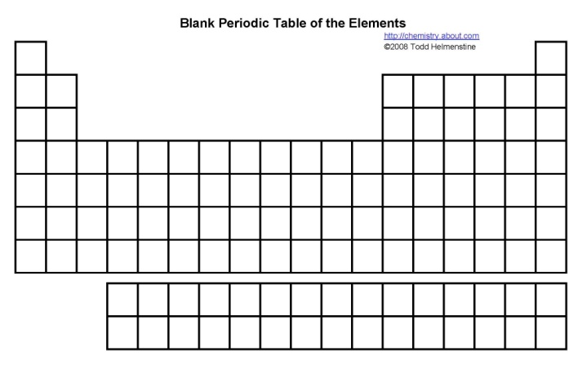

11. Know how to determine how many valence electrons an element has using its electron configuration?

Examples:

K-

Ca-

Al-

Ge-

Br-

Ar-

12. Which color has the longest wavelength and lowest frequency? Shortest wavelength and highest frequency?

13. What is the difference between an electron in the ground state and the excited state?

14. What happens when excited electrons return to the ground state?

1. Emission of light from an atom occurs when an electron

a. drops from a higher to a lower energy level.

b. jumps from a lower to a higher energy level.

c. moves within its atomic orbital.

d. falls into the nucleus.

15. What is an atomic emission spectrum?

16. What is meant by wave-particle duality?

17. Describe the photoelectric effect.

18. What are photons?

19. What does the Heisenberg uncertainty principle state?

20. The SI unit of cycles per second is called a ___________.

21. How does the energy of an electron change when the electron moves closer to the nucleus?

a) It increases

b) It decreases

c) It stays the same